**FIT3179 Data visualization**

**Data Visualization 2**

Chongbo Zang

Student ID: 28291239

Lab: Wed 8 am

Tutor: Joe Liu

Table of content

1. Domain 3

2. Screenshot of visualization 3

3. Munzer’s What/Why/How framework 3

4. Design 4

5. Alternative design 6

6. Interactivity 6

7. References 7

8. Appendix A: 5 Design Sheet Methodology 8

9. Appendix B: Screenshot of Data Visualization 1 10

10. Appendix C: Assignment 1 proposal 11

1. Domain

Electric vehicles are a new technology and will be developed faster in the next few decades. It can not only save energy (reduce petroleum extraction) and reduce environmental pollution (CO2), but also bring convenience and improve the life quality. Therefore, this visualization will mainly focus on electric vehicles (EV) and use the database published by kaustubh (2021) on Kaggle to create innovative visualizations. This visualization is based on 179 different models of electric vehicles designed by 37 well-known and industry-leading manufacturers. The target user of this visualization can be assumed to be people who analyze the data of existing electric vehicles, or people who want to buy cars based on the performance of electric vehicles reflected in the data.

Sold

https://www.kaggle.com/ruizjme/realestate-vic-sold/version/4

1. Screenshot of visualization

Figure 1a is generated by tableau showing the general appearance of this visualization (large-scaled figure show in Appendix B) and an accessible link is attached below.

Figure 1a: Data visualization 1 - Electric vehicle Visualization

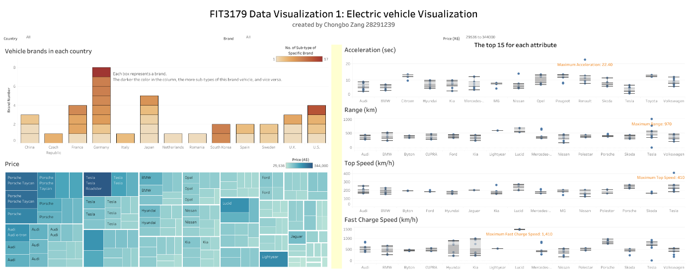

Access URL:

<https://public.tableau.com/views/Datavisualisation1ElectricvehicleVisualization1/Dashboard1?:language=en-US&publish=yes&:display_count=n&:origin=viz_share_link>

1. Munzer’s What/Why/How framework

This database provides the name of the vehicle model, various properties or performance and prices. Therefore, first determine what type of attribute each data is (show in Table 1), and then design the dataset type. According to the questions (Which brand has better performance or price?) in the why part of the proposal (show in Appendix C), we need to design a chart to show the maximum, minimum and median values of each performance of each brand car, so a box whisker plot will be particularly suitable. However, the name attribute has a lot of data (179), when making a chart, an axis will be very long and it’s not suitable for observing the trend of the chart, so I categorize them by brand (37). After that, I added the country attribute because the country of manufacture is also one of the factors that people consider when buying a vehicle. At the same time, the price of a vehicle is also an important factor, therefore, a price chart must also be designed. Finally, according to the revised and cleaned database, I designed three different data types which are bar chart, tree-map, and box whisker plot.

Table 1: Determination of attribute type



In the upper left bar chart of Figure 1a, the x-axis represents the countries which have electric vehicles (Categorical) and the y-axis represents the number of electric vehicle brands in a country (Quantitative). Each box in the chart represents a brand, and its color intensity represents the number of sub-types in this brand (Quantitative), the darker the color, the greater the number of sub- types, and vice versa (mark: color luminance). It also uses position channel for both directions.

The lower left corner is a tree-map, the hierarchical structure over a quantitative attribute (price) and categorical attributes associated with nodes. The mark channel is that area proportional to quantitative attribute and color luminance represents the price. Its scalability is limited because without interactivity only the large region has visible labels.

The charts on the right are box whisker plot. The box and dot marks are all represented quantitative. The position channel is used for both directions (quantitative for y-axis and Categorical for x-axis).

1. Design

The entire visual layout is horizontally designed and divided into five parts, with the title at the top, followed by a line of filters, and the lower part is equally divided into two sides, with two charts on one side and four on the other (equal space). A rough chart segment, line of sight and alignment are shown in Figure 2.

Figure 2: chart segment, line of sight and alignment

Figure 3 shows two color designs for the bar chart, the color hue on the left is used to distinguish the country, and the color luminance is used in each column to distinguish the quantity attribute, but the ink-ratio is still very large. Therefore, it was later changed to the right, the color luminance only represents the quantity attribute. The tree diagram has the same logic, in order to distinguish two different attributes, blue is selected to represent price (show in Figure 4). However, in the box whisker chart, I used colored annotation to indicate the maximum value as same as the tooltip in tree-map (show in figure 5).

Figure 3: Two color designs for the bar chart

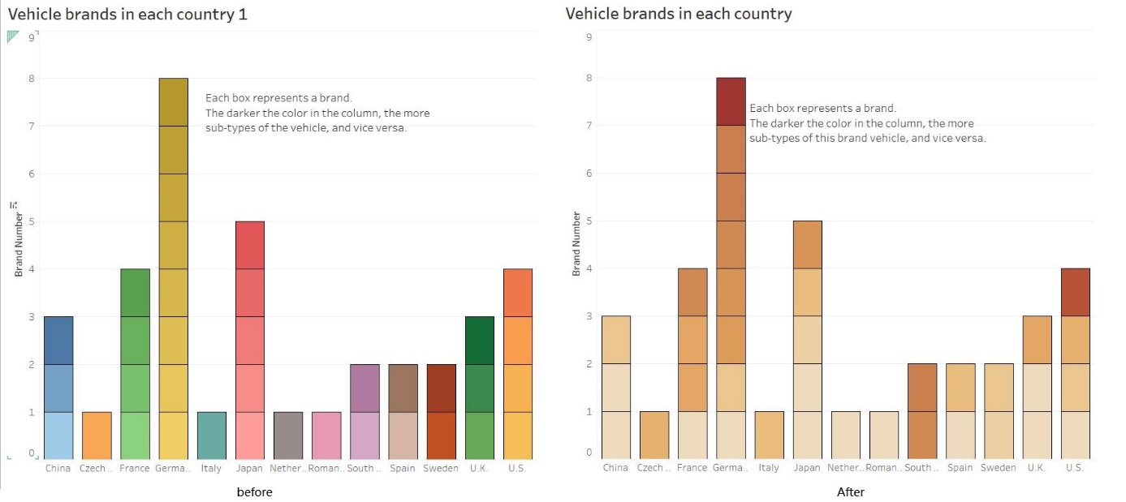

Figure 4: Two color for different attributes

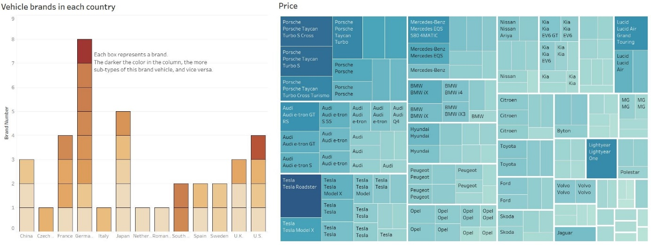

Figure 5: colored annotation and color band

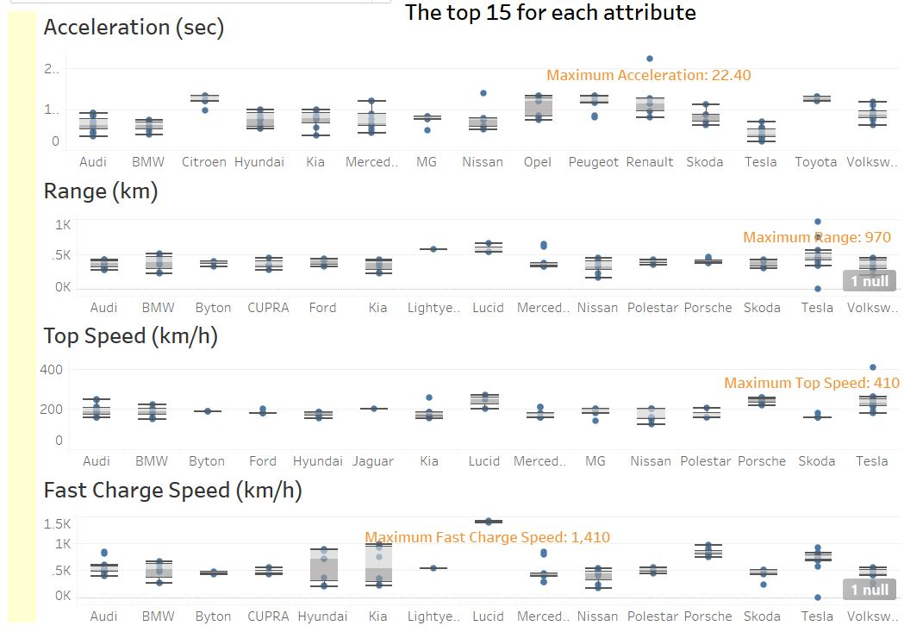

The figure-ground principle is used such as colored annotation contrast with the right grey color of non-important information. In the main chart part, I used a color band (reduce transparency) to separate the left and right sides, and the rest were left blank (show in figure 5). Sans Serif is used for the entire visualization typeface, which is a modern and new font and easier to read. All title has bolded which create visual hierarchy. This visualization mainly uses the partitioned poster method to realize the line of sight and reading from left to right and top to bottom. 5 Design Sheet Methodology drawings are attached in appendix A.

1. Alternative design

The chart part can be divided into three equal parts, and the right side can be elongated (accounting for two equal parts) to show more compared data. The alignment of the chart can be changed by referring to the title above. A new designed but rough layout and sight line are shown in Figure 6.

Figure 6: chart segment, line of sight and alignment for alternative design

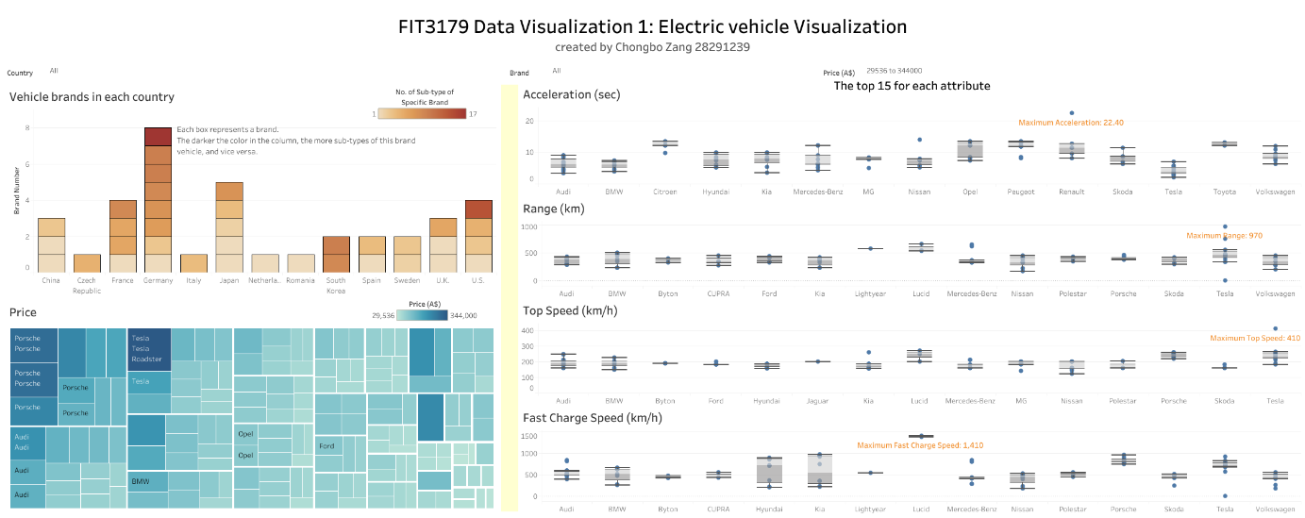

1. Interactivity

This visualization can be interacted in the following four ways. The first is through the filter as shown in Figure 7. Click the dropdown arrow to select the country, brand and price of interest. It can also click on any one or more squares in the bar chart to view the corresponding vehicle performance and price (show in Figure 8). By clicking on the country, you can view the ca vehicle parameters of all brands in this country (Figure 9). Figure 10 shows that by randomly selecting some areas in the tree diagram, we can know which country these come from, as well as the total count and vehicle parameters. Use any filter method to get the four charts on the right. If the same brand appears in the four charts, then it means that this brand is ranked in the top 15 and it is more worth buying.

Figure 7: Interactive with filter

Figure 8: Interactive with brand

Figure 9: Interactive with country

Figure 10: Interactive with price

1. References

koustubhk. (2021). Cheapest Electric Cars - Electric Vehicle Database [Data file]. Retrieved from <https://www.kaggle.com/kkhandekar/cheapest-electric-cars>

1. Appendix A: 5 Design Sheet Methodology

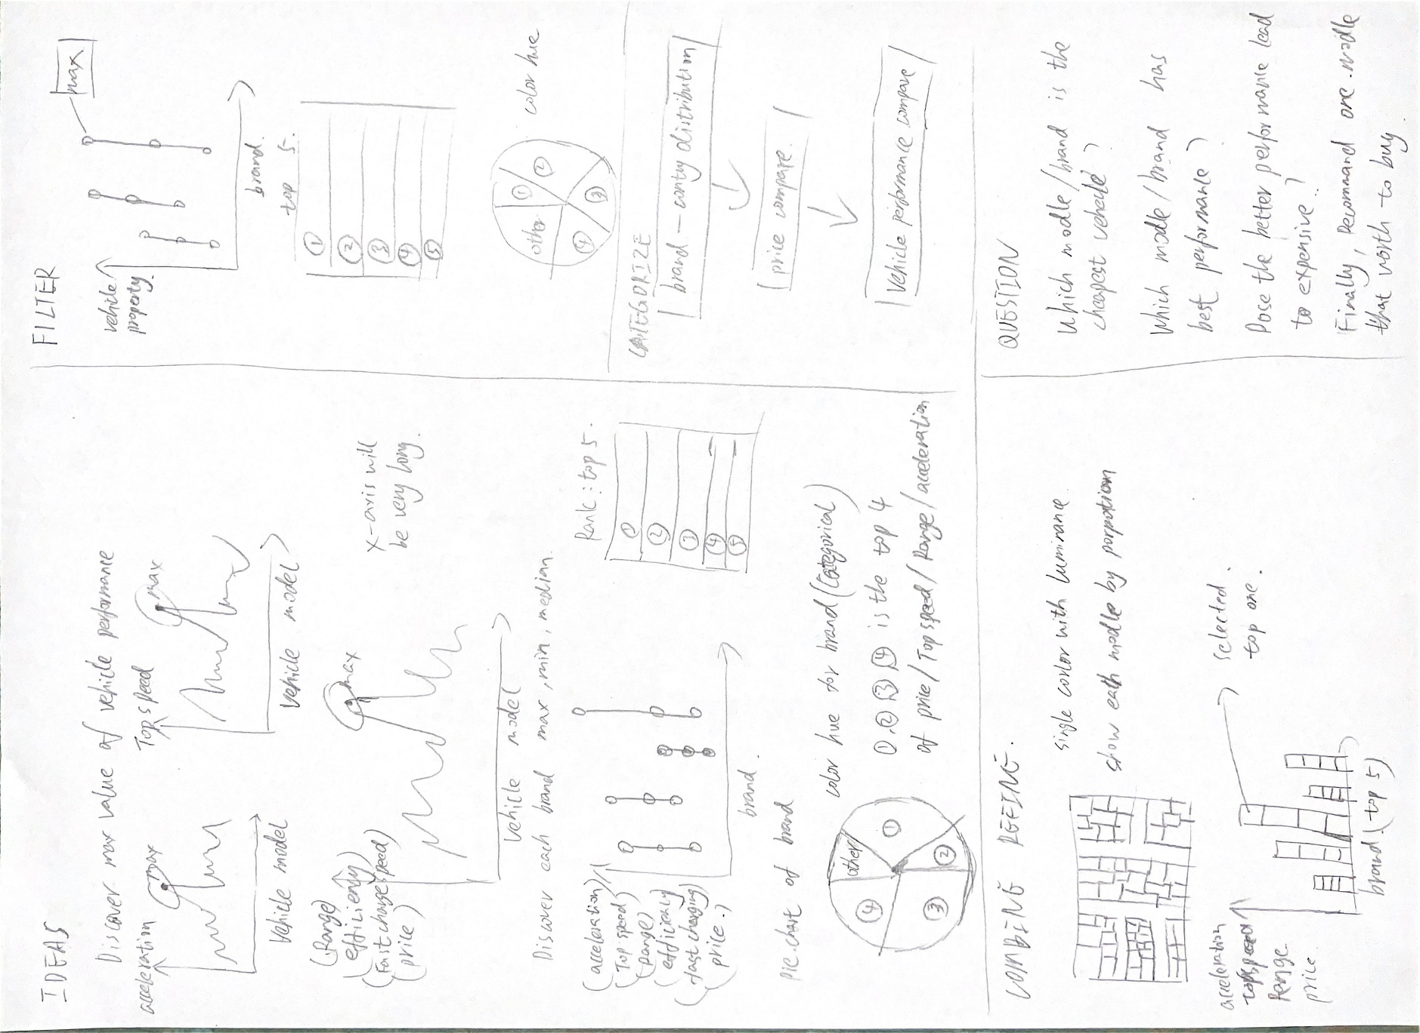

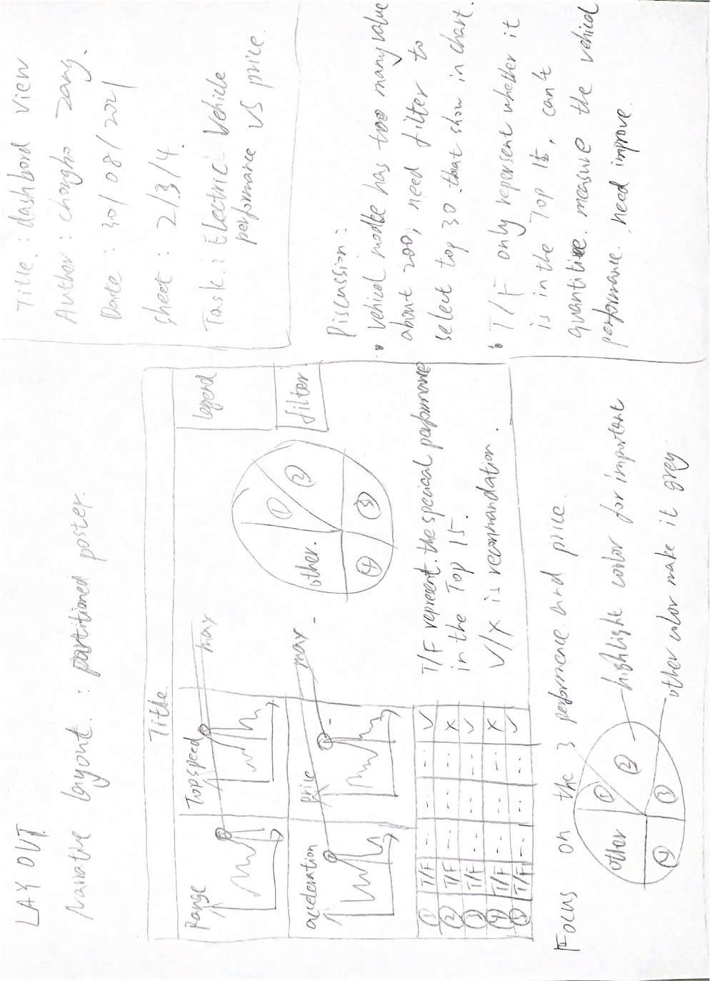

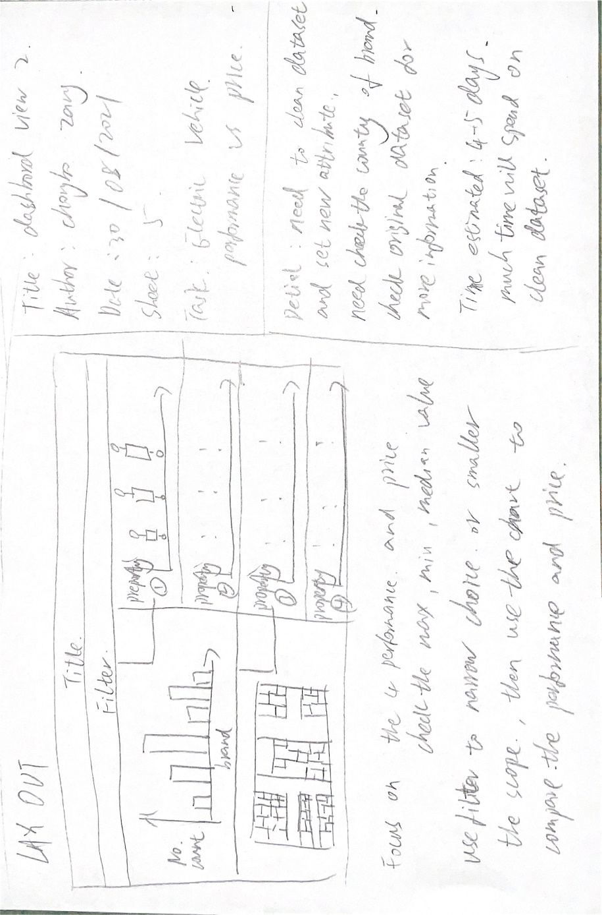

1. Appendix B: Screenshot of Data Visualization 1

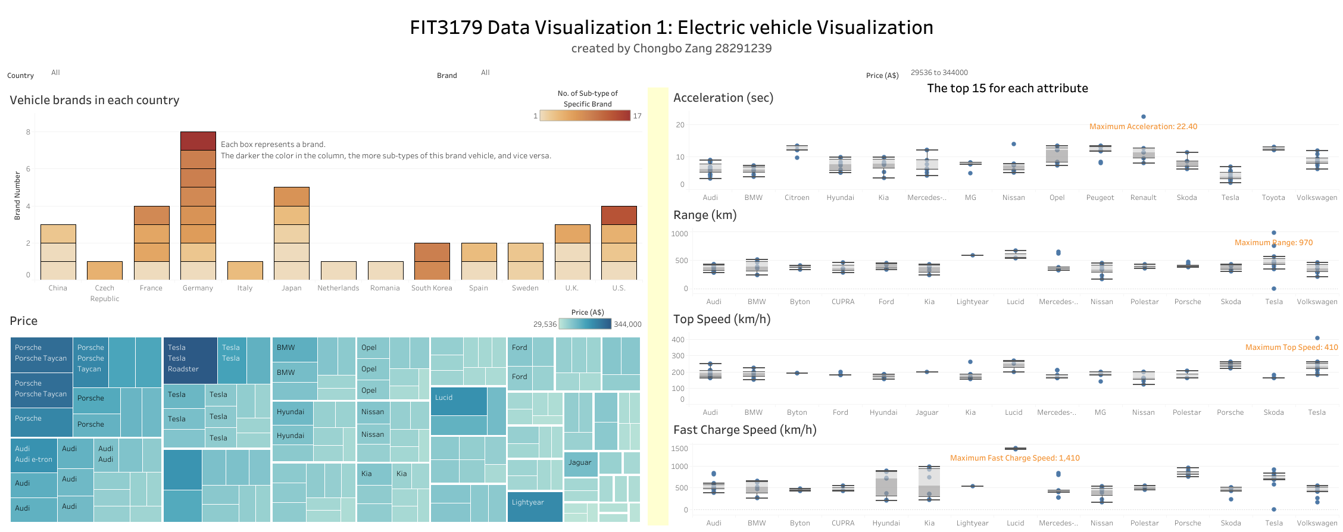

Figure 1b: Data visualization 1 - Electric vehicle Visualization

1. Appendix C: Assignment 1 proposal

1. Domain

Almost all Electric Vehicle in the world.

2. Why?

Which brand has better performance or price?

3. Datasets

<https://www.kaggle.com/kkhandekar/cheapest-electric-cars?select=CheapestelectriccarsEVDatabase.csv>

This website provides the Electric Vehicle basic information. For example, Model name, acceleration, top speed, price, ect.

4. Design ideas

Base on the brand group them. (Audi, BMW, Nissan),

Select the max, mini and median of each attribute in each brand (acceleration, top speed, efficiency, fast charg speed, price).

Create a rank based on each attribute (acceleration, top speed, efficiency, fast charg speed, price).

Figure: A Sketch of simple designed box plot

